

Final Year Project Proposal

Furniture Shopping AR (augmented reality) app

Submitted by
Rabbia Rauf (10772)
Rehan Ashraf (11452)
Shariq Ali Khan (10771)

Superviser
Ma’am Rida Fatima

List of Abbreviations and Acronyms

AR Foundation (Augmented Reality Foundation).

AR (Augmented Reality).

App (Application).

Table of Contents

Description Page #

Section – 1 1
1.1 Project Identification 1
Section – 2 5
2.1 Background 5
2.2 Outcomes and Benefits 6
2.3 Objectives 6
2.4 Research Approach 7
2.5 Risk Analysis 8
Section – 3 9
3.1 Resources & Other Requirements 9
Annexure–A: Project Schedule / Milestone Chart 11
Annexure–B: Proposed Budget 12
Annexure–C: Business Canvas Model 13
Bibliography 14

Final Year Project Proposal

Section – 1

1.1 Project Identification
Project Title:
Furniture Shopping AR (augmented reality) app

Group Leader (GL):
1. | Name: |  | Rehan Ashraf
 | Reg #: |  | 11452
 | CGPA: |  | 2.7
 | Mobile # : |  | 0336-2196223 |  | Email: |  |  |  | rehanashraf1997@gmail.com
 | Signature:
Group Members (GM’s):
2. | Name: |  | Rabbia Rauf
 | Reg #: |  | 10772
 | CGPA: |  | 2.96
 | Mobile # : |  | 0322-8262456 |  |  |  |  | Email: |  | rabbiarauf97@gmail.com
 | Signature:
3. | Name: |  | Shariq Ali Khan
 | Reg #: |  | 10771
 | CGPA: |  | 3.03
 | Mobile # : |  | 0336-1807713 |  |  |  |  | Email: |  | shariqkhanyousufzai@outlook.com
 | Signature:
What technology is core to your product?
[ ] 3D/4D Printing |  | [☑] Augmented Reality / Virtual Reality
[ ] Big Data, Artificial Intelligence |  | [ ] Blockchain
[ ] Cloud |  | [ ] Neurotech
[ ] Robotics |  | [ ] Shared economy
[ ] The Internet of Things |  | [ ] Wearables, Implantable
[ ] Others (specify):

What is the target market(s) for the products?
[ ] Automotive, aviation, marine |  | [☑] Business, marketing, finance
[ ] Defense, security, safety |  | [ ] Education and training
[ ] Environment, water management |  | [ ] Entertainment, tourism, sport/recreation
[ ] Food, livestock, agribusiness |  | [ ] Healthcare
[ ] Infrastructure, housing & transport |  | [ ] Mining equipment technology & services
[ ] Oil, gas, energy |  | [ ] Textiles, clothing, footwear
[☑] Others (specify): | Online Furniture Market.

Other Organizations Involved in the Project:
Academic Organizations:
# |  | Organization Name |  |  |  |  | Role / Contribution
 |  | Iqra University |  |  |  |  | Final Year project
Industrial Organizations:
# |  | Organization Name |  |  |  | Role / Contribution
Funding Organizations:
# |  | Organization Name |  |  |  |  | Role / Contribution
Key Words:
- Augmented Reality.
- Virtual Reality.
- AR Foundation.
- Furniture.
- Ecommerce App.
- AR Ecommerce

Research and Development Theme:
AR (Augmented Reality) Foundation.

Project Status: (Please mark ☑)
[ ☑ ] New [ ] Modification to previous Project
[ ] Extension of existing project

Project Duration: |  |  |  | 8 Months
Proposed Budget: |  |  |  | 442,000 PKR
The Problem:
There are two problem through which we decide to solve this through AR Foundation the new technology AR (Augmented Reality) and E-Commerce.
The 1st problem is there is no online store for the furniture in Pakistan who are using Augmented reality (AR) to show people model’s virtually on their mobile screen, and view furniture virtually is important because many of people not trust on images for buy furniture online. So mostly people want to check it physically.
The 2nd problem is that there is no platform for furniture shop keeper to open there online shop in which people see the furniture online and purchase furniture.

Following are some of the well-known (identify the best known if possible) existing solutions to this problem. Their known strengths and weaknesses are also provided.
The well-known and existing solution is ikea place application. Ikea Place is an AR (Augmented Reality) application that let’s put furniture on the anywhere people need. Their strength is that Ikea has released its own AR app to help customers visualize what their furniture might look like in their own rooms. The weakness is this they only build this application for only for them.

Our solution will address the following weaknesses of above mentioned solutions.
Our solution for the following weakness is to build an Application that providing a Big platform to furniture store to start their store online with new technology AR (Augmented Reality), all furniture store can register in our application and easily sale their all stuff they also give us the 3d model of their furniture. Also for Customers because in picture they have no idea how the furniture looks in house so now they check virtually in their own place and also change color and check actual size through that amazing technology augmented reality.

We will use the following techniques to achieve improvements mentioned above.

We use the techniques to do this thing is

- Before starting to build this application we visit furniture store’s and let them explain our application.
- For Augmented Reality we use AR Foundation.
- AR Foundation helps us in augmented reality for android.
- We create web API and integrate in unity 3D for online shopping (E-commerce).

Synopsis:
Do you want to buy furniture sitting at home? So with the help of AR technology we decide to introduce an E-Commerce Furniture AR app that helps you to see the size of furniture virtually and then decide that you want to buy that furniture or not and you can easily buy through our furniture AR app.

Furniture AR app lets you virtually place products in your space select other product and add them to your room to make new look and feel of your place.

Tap through the app’s catalogue includes furniture and decoration elements from the companies, the customer can sort products by price, style, color or brand. The latest updates make it possible not only place the objects. The full collection of sofas, armchairs, coffee tables, and storage units, then holds up your phone and use the camera to place the digital furniture anywhere in a room.

Through the camera, and touch items on screen to add them to their shopping cart.

Makes it easier to make buying decisions in your own place, to get inspired and try many different products, styles and colors in real-life settings with a swipe of your finger.

Section – 2

2.1 Background
Scope of the Project:

The Scope of this project is to develop an Augmented reality furniture shopping application through AR (Augmented Reality). AR (Augmented Reality) E-commerce furniture store where any kind of interior product can be bought for the comfort of home through the internet and with the new technology Augmented reality that helps us to find the perfect size of furniture you need for your rooms you can see 3D models of those product virtually.

A Furniture AR online store is a virtual store on the internet where customers can easily browse the catalog and select interior products of interest. The select items may be collected in a shopping cart. At checkout time, the item in the shopping cart will be presented as an order. At that time, more information will be needed to complete the transaction. Usually, the customer will be asked to fill or select a billing address and payments information such as cash on delivery and integrate cards. An email notification is sent to the customer as soon as order is placed.

Literature Review:

It’s the kind of embarrassing decorating mishap most of us have faced at some time. You choose a beautiful sofa or dining table and excitedly take it home, only to find it doesn’t match the rest of the room. Or it doesn’t quite fit the space you had in mind.
Now that kind of headache is fast becoming a thing of the past, thanks to augmented-reality (AR) technology and some serious IKEA know-how. Launched in the autumn of 2017, the IKEA Place app lets customers see exactly how more than 2,000 furniture items would look - and fit - in their homes.

Accurate down to the millimeter
Michael Valdsgaard explains IKEA Place makes use of Apple’s AR Kit augmented reality platform and takes the experience to a whole new level. The app is easier to use and places photorealistic furniture items in the frame at the touch of the screen. Furniture is correctly sized down to the millimeter and you can walk right up and get a close up look at fabrics and colors. Of the 2200 items that can be tried for size, most are larger items found in the living room, such as sofas and coffee and dining tables.
Launched in the autumn of 2017, the IKEA Place app lets customers see exactly how more than 2,000 furniture items would look – and fit – in their homes.

Reference of research:
By DANIEL DASEY
Current State of the Art:
Ikea Place is an AR (Augmented Reality) application that let’s put furniture on the anywhere people need. Their strength is that Ikea has released its own AR app to help customers visualize what their furniture might look like in their own living rooms. The weakness is this they only build this application for only for them.

We build an Application that providing a Big platform to furniture store to start their store online with new technology AR (Augmented Reality), all furniture store can register in our application and easily sale their all stuff they also give us the 3d model of their furniture. Also for Customers because in picture they have no idea how the furniture looks in house so now they check virtually in their own place and also change color and check actual size through that amazing technology augmented reality.

Challenges:
The challenge is to load 3D model fast and smoothly, the quality of 3D render will be best, performance should be best, manage big data for 3D models and shop keeper profiles.

Motivation and Need:
- There is no platform for furniture shops to sale their goods online.
- Mostly people wants to buy furniture sitting at home because of minimal time.
- There is issue to buy furniture at home is “Size” issue.
- There are no Furniture AR Shopping Store in Pakistan.

2.2 Outcomes and Benefits
Expected Outcomes:

- Android Application.
- AR Core Supported Application.
- E-commerce Application for Furniture.
- Big online store application for furniture.
- Databases of customers and products (3D model).

Key Benefits and Beneficiaries:

There are two types of user in this application:
- Furniture Shop owners (Those sale goods).
- Customers (Those buy goods).

Benefits for Furniture Shop owners (Those sale goods):

- All Furniture shop owners register and create their own online store in our app.
- Share their models with Customers (Those buy goods).
- They also have rights to active sale on their product and their online store.

Beneficiaries for Customers (Those buy goods):

- They easily watch furniture virtually on sitting at home through mobile.
- They also view accurate size of the furniture they need.
- They also get review from upload the SCREEN SHOT on social media.

Technology Transfer/Diffusion Approach:

The “APK” of our project is upload on “APP STORE” and all “AR CORE” supported android user will easily use this application.

2.3 Objectives
The objective of this project is to develop an Augmented reality furniture shopping app through this AR e-commerce furniture store where any kind of interior product can be bought for the comfort of home through the internet and with the new technology Augmented reality that helps us to find the perfect size of furniture you need for your rooms you can see 3D models of those product virtually. A Furniture AR online store is a virtual store on the internet where customers can easily browse the catalog and select interior products of interest. The select items may be collected in a shopping cart. At checkout time, the item in the shopping cart will be presented as an order. At that time, more information will be needed to complete the transaction. Usually, the customer will be asked to fill or select a billing address and payments information such as cash on delivery and integrate cards. An email notification is sent to the customer as soon as order is placed.

The user interface of the application should be less complicated i.e. the user should not have problem in understanding the application.

The application should encrypt user password for reliability.

Database should be updated.

Accurate bill should be generated on order placement.

Application should be compatible with different android phone versions after nougat 7.0.

Payment details should be encrypted for protecting data integrity.

Registration should be compulsory for order placement.

Guest login cannot place order.

Data should not be redundant, that is duplicate IDs should not be created.

Users shall not be able to upload any type of product.

Admin should have the right of uploading models.

The store person can only view the history of product and its description.

3D model should be generated within 60 seconds.

The size of the 3D model should be same as defined.

Our app can adapt a new change like new shops can be include in our APP, new user can easily use our APP, new offers can be update on our APP.

4 Research Approach
Development / Research Methodology:
- We develop our application in unity 3D for AR (Augmented Reality) Core through AR Foundation.
- We build our application for android that’s why we prefer AR Core.
- To make E-Commerce application we make web API’s on PHP and integrate it in unity 3D.

Key Milestones and Deliverables:
S. No. | Elapsed time since start of the project | Milestone | Deliverable
1. | Week 01 – 04 | Idea discussion, research | Finalize idea.
2. | Week 05 – 08 | Requirement gathering. | Study research papers.
3. | Week 09 – 12 | Requirement Modeling | Proposal and Diagrams.
4. | Week 13 – 16 | Prototype and Poster. | Idea Poster and Prototype.
5. | Week 17 – 20 | Architecture. | Application Analyze
6. | Week 25 – 24 | Designing and developing front end. | Mobile application UI.
7. | Week 25 – 28 | Developing back end. | Mobile Application with Functionality.
8. | Week 29 – 32 | Testing. | Full Functional Mobile Application without bugs.
9. | Week 37 – 36 | Project Defense and presentation. | Defense project and make presentation.
10. | Week 37 – 40

2.5 Risk Analysis
Risk | Likelihood  (Low, Med, High) | Impact | Mitigation

Section – 3

3.1 Resources & Other Requirements
Project Team:
Title / Position | Number
Team Leads | 1
Researchers / Developers | 1
Researcher / Development Assistants | 1
Support Staff
Contract Staff (please specify)
Others (please specify)
Add more rows if required
Team Structure:
Team Leader
Rehan Ashraf

Requirement Gathering
Rabbia Rauf, Shariq Ali khan, Rehan Ashraf

Designer
Rabbia Rauf, Shariq Ali Khan
Developer
Rehan Ashraf, Shariq Ali Khan

Testing
Rehan Ashraf, Rabbia Rauf, Shariq Ali Khan

Title/Position  (of each member) | Role/Key Responsibilities | Minimum Qualification Required | Expertise / Background Required | Minimum Experience Required (years)
Team Leader:  Rehan Ashraf | Leads a team and guide them.
Requirement Gathering:  Rabbia Rauf, Rehan Ashraf, Shariq Ali khan | Gathering and maintaining database.
Designer  Rabbia Rauf, Shariq Ali Khan | Front and designing.
Developer  Shariq Ali Khan , Rehan Ashraf | Backend development.
Testing  Rehan Ashraf,  Rabbia Rauf,  Shariq Ali Khan | Testing at every phase.

Remarks:

1. Name & Signature of Supervisor: Ma’am Rida Fatima

Annexure–A: Project Schedule / Milestone Chart:

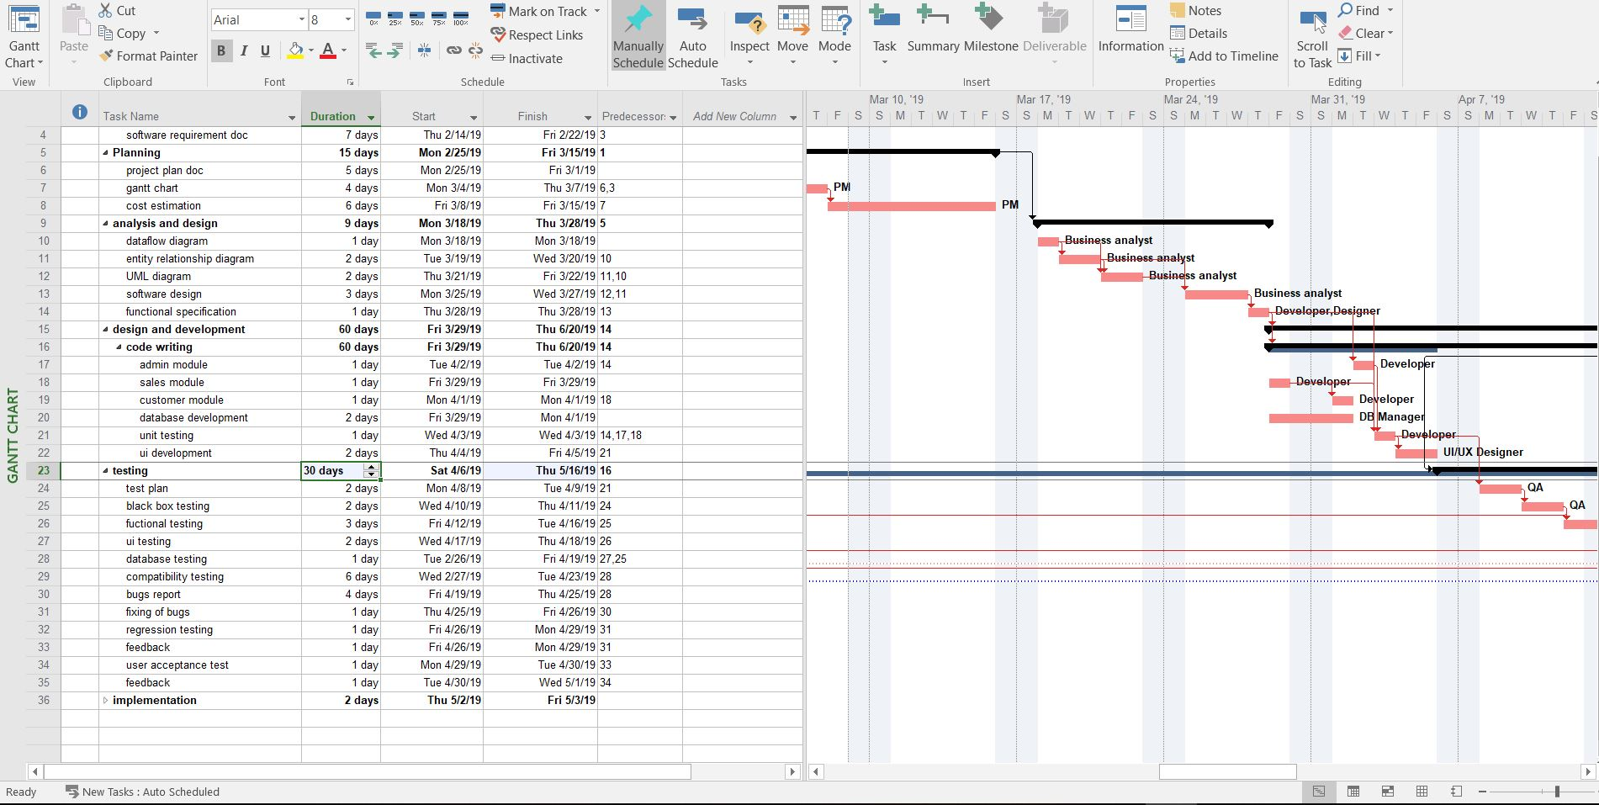

Annexure–B: Proposed Budget

Please use the embedded Excel Worksheet for providing budget details.

Double click the icon to open the worksheet.
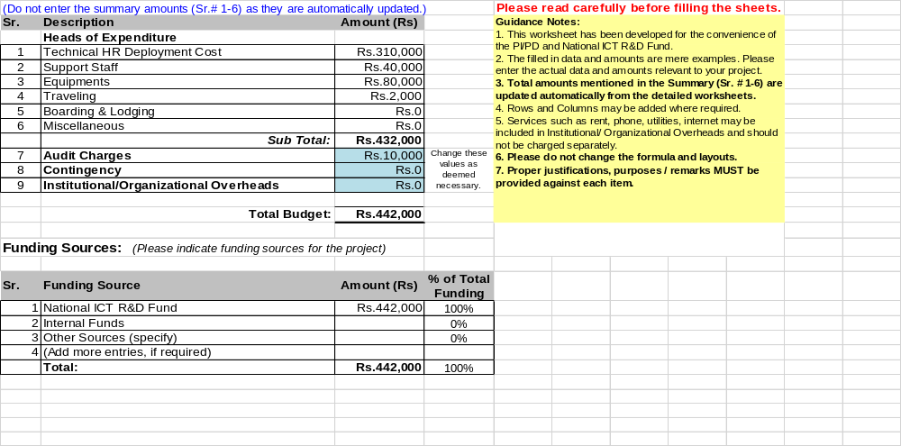

Annexure–C: Business Canvas Model
Key Partners:  Retailer.  Customers. | Core Business:  Marketing and sale the Furniture. | Value Proposition:  All Customer easily buy the furniture through our application through the technology AR (Augmented Reality).  Retailer Can create the online shops and easily create and sale the furniture. | Customers Relationship:  We fulfill the customers need give them the view of 3d model virtually through AR mode. | Customers Segments:  - All People who wants to buy the furniture.  - Retailers who wants to create their shops online.
Key Partners:  Retailer.  Customers. | Key Resources:  Factory and the company those manufacture the furniture. |  | Channels:  The products is of furniture retailer we are just the 3rd party deal with the retailer and the customers.
Cost Structure:  Development and design is the biggest cost in project. | Revenue Streams:  Revenue generate through the retailer and the users who us the applications.

Bibliography

We use ikea furniture application for our research.

Reference:

https://highlights.ikea.com/2017/ikea-place/

Author Name:

Daniel Dasey.

